From: Dalei Yang
Sent: Saturday, December 5, 2015 10:26 AM
To:
Subject: XXXXX cache improvement architecture and testing results

Hi all, I want to address a new design for XXXXX cache improvement task. Please let me know what you thought, and I want to arrange a meeting to give you more detailed explanation.

System Architecture
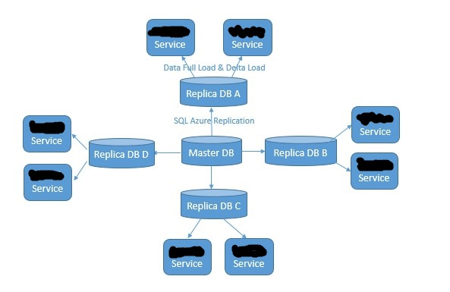
Major benefit from this design

- Total cost is the same as current.
- User’s changes will push to XXXXX service in 30 seconds. (Could be faster)
  - It takes 5-6 seconds to sync up data change from master DB to replica DB.
  - XXXXX service gets new data change every 20 seconds.

Based on 1.1 and 1.2, user’s change which are made in the backend tool will take effect in frond-end XXXXX service in less than 30 seconds.

- Ensure data consistency between XXXXX service and master DB.
  - SQL Azure ensures data consistency between master database and replicas.
  - Revised SQL query doing full load and delta load to make sure no dirty and duplicated data getting into XXXXX service.

There are bugs in the candidate SQL query to get dirty data from database: “with(nolock)” query hint is used extensive in the current full load and delta load which will result in loading un-committed data into XXXXX service.

- Provide 148,923 PRS capability with 9 D5V2 instances.
One D5V2 instance could provide 16,547 PRS capability, we could use 9 instances to provide 148,923 PRS capability.

- Fast initialize speed, XXXXX service need 4 minutes 17 seconds to initialize.
Each XXXXX Service need 4 minutes 17 seconds to load updated full data set and ready to serve incoming request.

Initial full load takes 4 minutes and 13 seconds.

The first time delta load takes 4 seconds. (One-month delta data)

The following delta load takes less than 1 seconds.

- Improve system availability and robustness.
  - 9 XXXXX services are independent. Each one has latest full dataset and could provide 16,547 PRS capability. If one down, others will not be affected.
  - A static full data set which is prepared in advance is required by XXXXX service initial loading process. We have five copy of this data set which locates in each SQL Azure replica database and master DB. If one is down, XXXXX service will look for another one.
  - XXXXX service delta load target will be the replica SQL Azure database in the same data center. If this one is down, XXXXX service will query other three replicas. If they all down, XXXXX service will query master DB.

- Minimize operation cost.
  - SQL Azure service takes care of master DB and replica DB sync up task.
  - If XXXXX Service instance is down, we need to reboot it, and it will back online in 5 minutes.

- Refactoring code base. New code’s NCSL is only 50% of original code base.

More findings. Maybe IIS is the bottleneck neck.
Essentially, XXXXX is a http package processing and forwarding service. In the candidate code, we override “ProcessRequest” function in the “IHttpHandler” interface to process and forward http package.

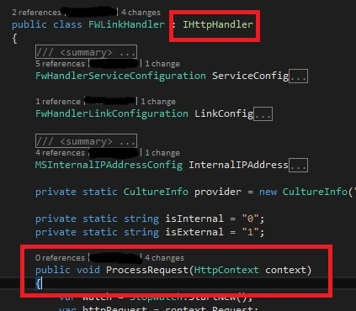

I did a test. I remove all the code in the “ProcessRequest” function, made it an empty function, did the stress testing in an Azure D5V2 instance. The result is 18,628 RPS with 100% CPU usage. This is maximum RPS we could provide in this environment.
That means with IIS, “IHttpHandler” and D5V2 box’s capability, the maximum RPS we could provide is 18,628 RPS. (Please notice that we get 16,547 PRS capability with a full functional XXXXX service in the same environment.)

I also check the network throughput in the same time. The result is 10 M/s receiving and 6.8 M/s sending with 18,628 RPS and 100% CPU usage in a D5V2 box.
Considering high CPU usage, low network throughput with a 1000 Mbytes/s network interface, I suspect the current software architecture and software stack we leveraged are bottleneck for a http package processing and forwarding service.

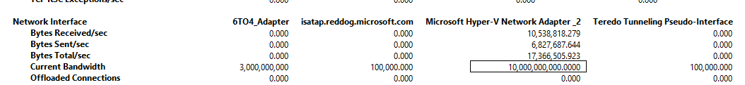

Thanks!
Dalei

